**Character**:

**Level**:

**Stat Points:**

**Max Health:**

**Who** are you? Who’s your family? Who do you want to be?

**What** are you? What do you look like? What do you own?

**When** are you adventuring? Are you young or old?

**Why** are you adventuring? Why with this group?

**Where** did you come from? Where are you going?

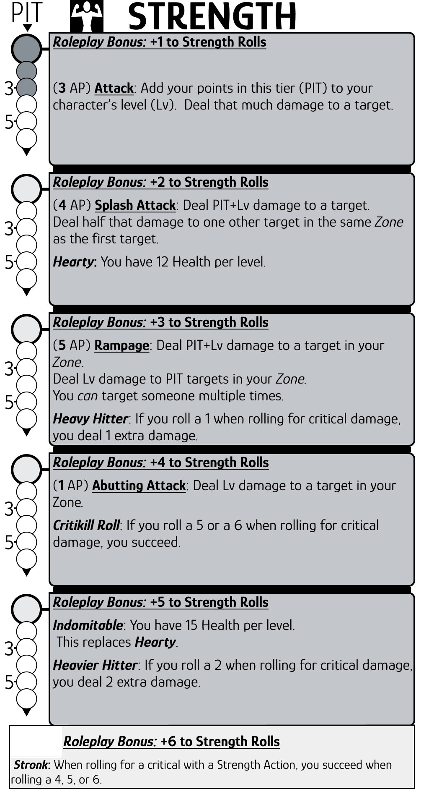

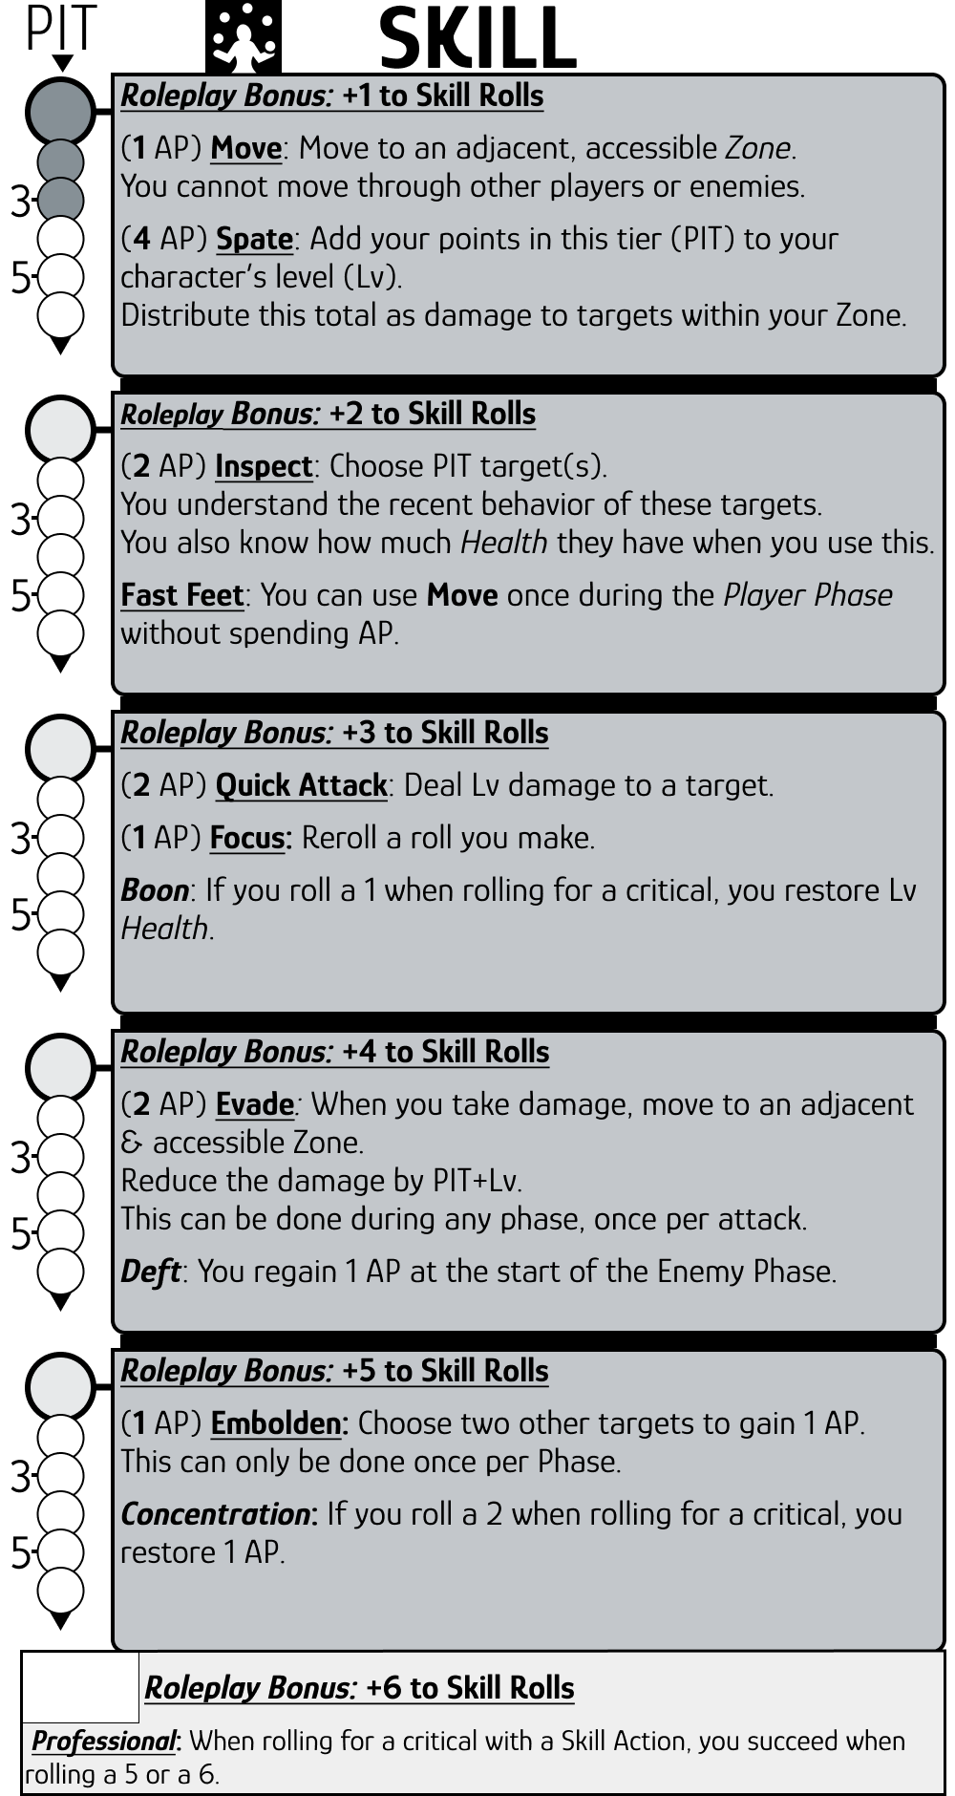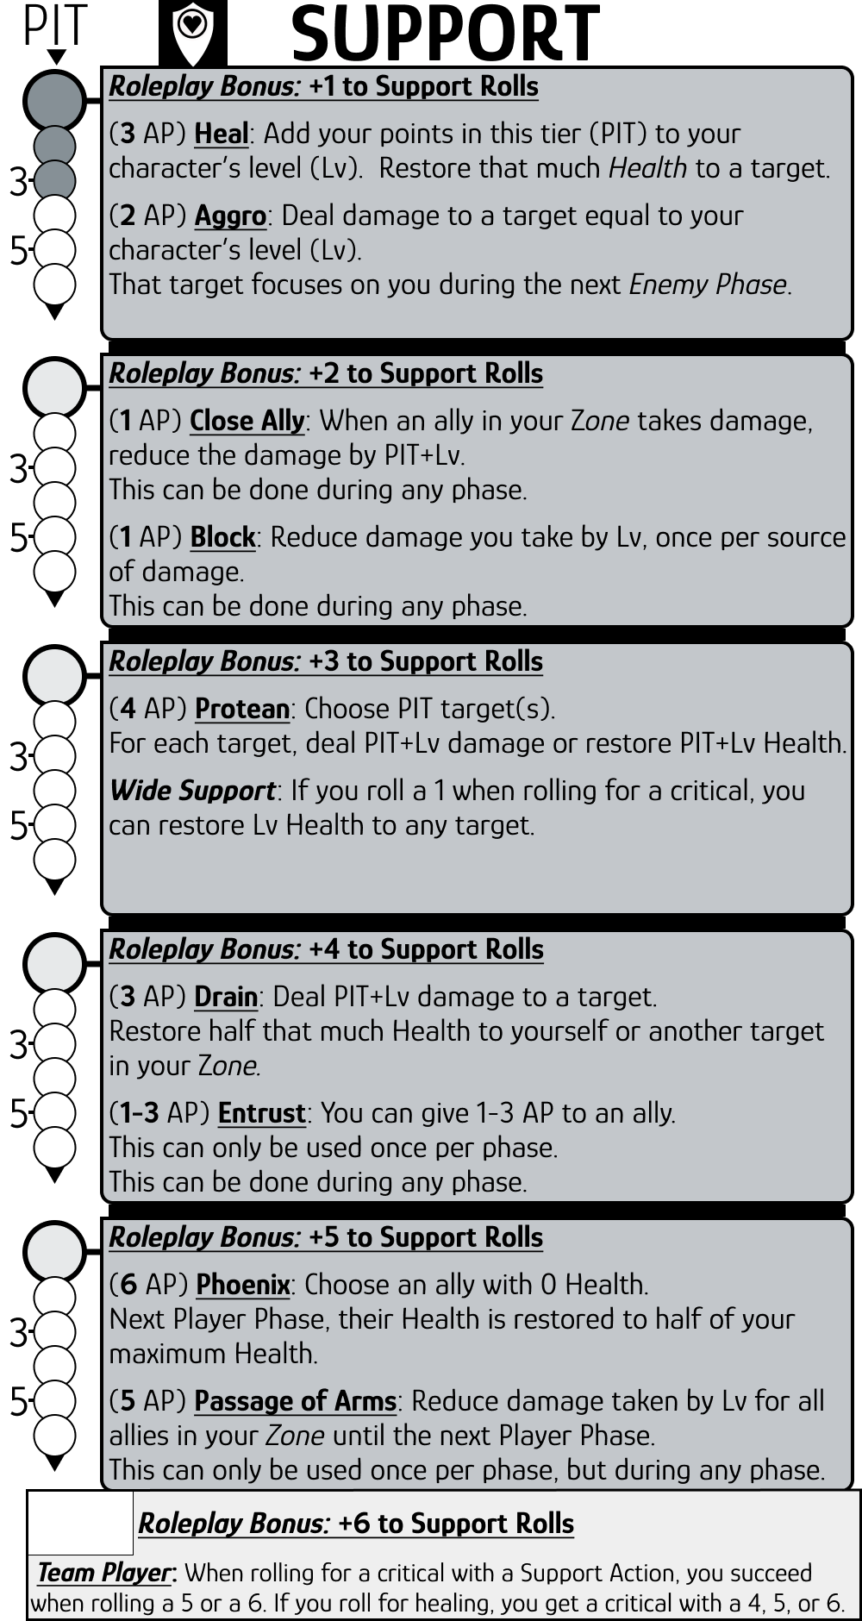

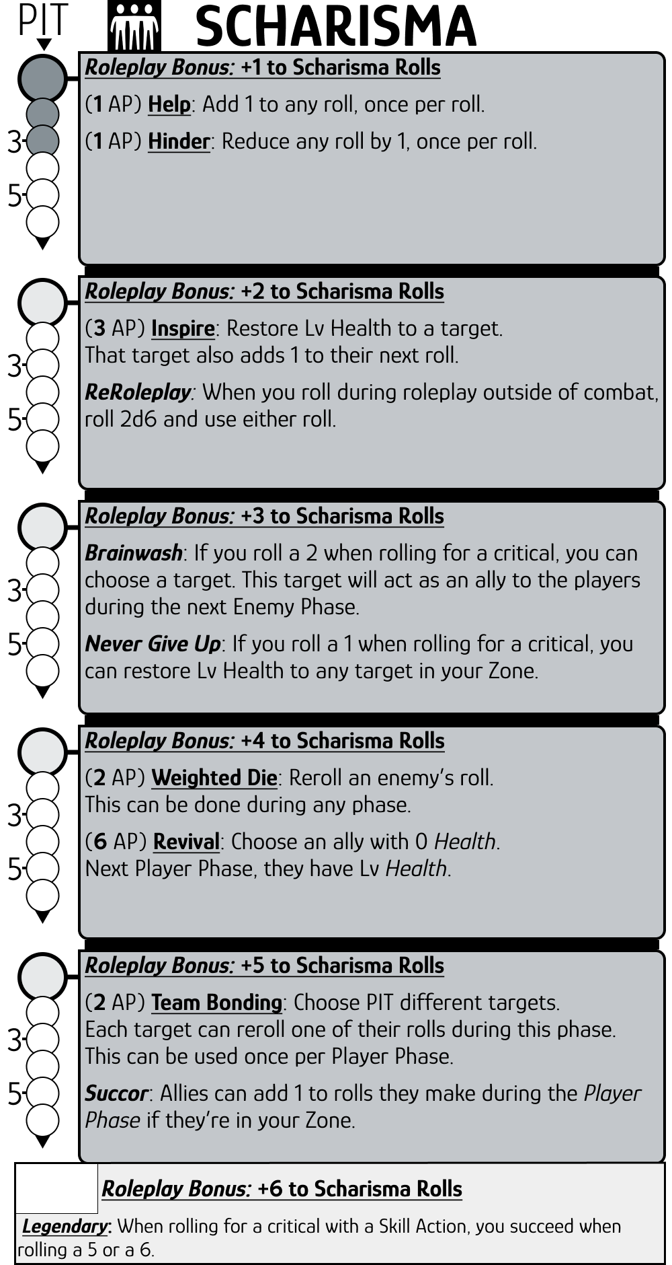

**NOTES**

## Action Points (AP)

Spend AP to do Actions.   
All players have 6 max AP, which are restored at the start of the Player Phase.

Ranged actions cannot shoot through inaccessible Zones.

](https://rolladie.net/)

**Rolladie.net**

**Items**

Spend 1 AP to use a Fast *Item*.

Spend 2 AP to use a Normal *Item*.

Spend 3 AP to use a Slow *Item*.

**Leveling Up**

Players have 10 Health and 4 Stat Points (SP) per level.

To **put SP in a tier**, you must have **6 SP in the previous tier**.

## Roleplaying in Combat

Roleplaying, like grappling an enemy or holding a door shut, can be done in **combat by spending 1 AP to roll 1d3** for these rolls.

**Add the Roleplay Bonus from your Stats!**

You can **spend more AP to add 1d3** to these rolls   
(1 AP per 1d3).

## Rolling for Criticals

After using an Action that deals damage or restores Health, roll 1d6.   
If you roll a 6, double your damage or healing!

## P.I.T

PIT stands for Points in this Tier. Playersstart with3 PIT in each Stat’s first tier.